WavesSaves
Final Project Definition

By:
Tomer Mantzuri
Zehava Liviyav
Itay Bayazi
Assaf Ben-Aroya
Ariel Varbitzsky

Supervisor:
Dr. Eliav Menashe

Git:
https://github.com/TomerMantzuri/WavesSaves

Table of Contents
1. Project description 3
2. Related Work 3
3. Functional Description / Requirements 3
4. Architecture 4
5. Work plan 4
6. Client side 5
6.1. Usage Illustration 5
6.2. Mockup 6
7. Server Side 7

Project description
Today in Israel there are a lot of drownings in home pools and deaths of children and animals.
We will develop an application and a sensor to help pool owners prevent such incidents when there is no adult in charge of the place.
First, we will build a system based on a sensor that sits on a float in the water and according to the wave movements in the pool the sensor will send a signal to the application that will trigger an alarm in the cellular devices of the pool owners who connected to the system.
When a child or animal falls into the water, waves will be created in the pool, which will cause the buoy to move in an extreme manner, sensor will detect an unusual event and send the signal to the phones who are connected to that sensor.
Then the application will receive the signal and activate an alarm /alert bypassing all active applications and keep going until the phone owner will stop the alarm.

Related Work
Today, there are sensors that send an alert only to a built-in stationary device installed in the home.
This solution does not guarantee us constant maximum safety, because the customer will not always be near the stationary device in his home.
Our solution is different because it is built on a mobile application that is based on the Internet and can connect to several devices simultaneously regardless of their location (home/office etc.).
In addition, the current devices are very expensive, a device costs approximately more than NIS 1,000 and is not convenient for every pocket.
our solution guarantees higher availability and safety in addition to the convenient price we will offer.

Functional Description / Requirements
Sign in and register functions - the customer register in the app at the registration page.
with the fields: username, password, email, phone number.
after registering, the application will send the user data to the server and the data will be added to the database on the server.
for existing users, login function by username and password, the server will match the user inputs to the username and password within the database.
The customer will scan a unique QR or ID which will do the synchronization between his personal sensor and his device.
After the initial interface, the server will bind the user and the serial number of the sensor in the database using foreign keys.
The app will constantly listen to the server and wait for a signal coming from the sensor.
Upon receiving the signal, the application will activate an alarm on the user's personal device.
The alarm will bypass all open applications even when the cell phone is "busy" with other features.
In addition, there will be shutdown/standby and start options (shutdown/standby for the time when the pool is in use / there is supervision in the pool).
In the settings the users can change the alarm sound or volume and display alerts history.
In addition, the application will have a function to change the sensor sensitivity.
A handler function which will read the UDP messages coming to the server which is transmitted from the devices and divert the actions according to the first word in the message (the key).
A contact us function which is intended for customer service which will open a panel in the application where the customer can address his issue, the message will be forwarded to an email address which will be used for customer service.

Architecture
On the server side we will have handler that will transmit all the data to the right destination the server will run a thread-pool.
On the client side, we will have the entire application, which we will take care of designing graphically in a user interface.
Regarding the database, we will make sure to validate all users in SQL tables with the fields:
First name, last name, phone number, email, password, username, and serial number that we will give to every user.
An external resource will be the sensor that we built.

Work plan
1st milestone – building the sensor and connecting it to a UDP server - Ariel.
Creating a UDP server and handle alerts from the sensor – Tomer and Ariel.
Creating a mobile app that handler different users – Zehava and Itay.
Mockup and user stories – Assaf.
Project definition – everyone.
2nd milestone – connecting the mobile app to the server and display incoming alerts – Itay and Zehava.
Sending the alerts to the mobile app, creating a database to hold app users + sending alerts only for users that connect to our sensor – Tomer Ariel Assaf.
Application design including alerts display – Assaf.
3rd-milestone – adjusting the sensor sensitivity and running dry tests– Ariel and Assaf
Finalizing the prototype for all 3 components – Tomer, Itay and Zehava.
4th milestone – permission functionality for the mobile app to display alerts on top of all apps and launching the app on the background to listen for incoming alerts - everyone
5th milestone – creating sensitivity and standby option on the mobile app – Assaf and Zehava.
Creating sensitivity and standby handlers on the server and sensor – Itay, Tomer Ariel,
6th milestone – finalizing server and mobile app design and functionality, running sensor tests - everyone
7th milestone – code optimization for all 3 devices and QA tests – everyone.

Client side
As for the client side, the android application called WavesSaves and the buoy sensor used by the client.
The mobile app will display the data coming from the sensor such as battery level, active communication, incoming alerts, alerts history, sensitivity level and more.
Using the app, the client will be able to initialize first communication with his sensor scanning a QR code or enter ID number.
In addition, the client will be able to browse throughout his sensor alert history and change the sensor sensitivity level.
There will be a possibility to connect to several sensors if the user wishes for.
The sensor will be a device client buying for a decent price, initializing first communication to their mobile device using the app and simply placing it inside their home pool.
The buoy will come with a small rope to prevent the buoy to float towards the filter or into a small waterfall or a fountain (which might shake the sensor and trigger a false alarm), which some clients might have in their pool.

Usage Illustration
The user logs into the application, he can choose to register or sign in if he already has an account.
For each function the user will be diverted to the relevant page.
For the registration page, the user will enter his username and password, and confirm his password, if all the details are ok the user will be diverted towards the home page, otherwise he will have to renter different password or username.
For sign in option the user will enter his own username and password and if the details match the user will move to the home page.
At the home page the user will see his listed sensors, if he doesn’t have any, the app will display a "connect a senor" button which will divert the user to the add a sensor page.
At this page, the user can enter an ID or scan a QR code to add his sensor.
For each sensor the user can edit the sensor details, such as sensitivity level or the name of the sensor as displayed on the app and a on/off/standby buttons.
In addition, the user will be able to see the level of the sensor battery and WIFI strength.

Mockup

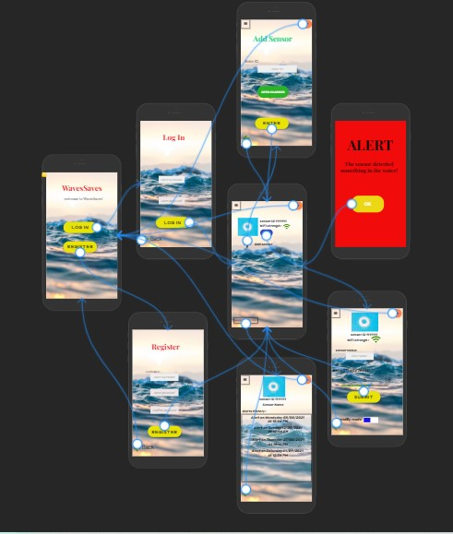

Server Side
As for the server side, the server will be a remote UDP server that holds all the database for users and sensors.
The server will run a thread-pool to handle multiple alerts/messages from different users and sensors.
Each sensor will be attached with a foreign key to one or several users(one-to-many).
First, when a client log /sign in the application send a UDP message containing the username and password, the server matches the user details with the database and return a message to the application if the details are ok or not.
After the sign in, the user will want to connect his app to his sensor, this connection will be made in the server, if the users hold the right ID for his sensor than the server will attach the user and the given sensor in the database using a foreign key.
As for initializing a sensor, once a sensor connecting to the server, if the server can't match the sensor ID in the database, then the server will add the current sensor to the database as a new sensor.
After the first connection has been made between a client and a sensor, whenever an alert will be sent by a sensor, the handler in the server will prioritized this message and find the related users in the database and send the alert for those devices immediately.
the server will send a message to the sensor to let the sensor know that the alert was processed and no need to keep sending alerts to the server.
In addition, the user will be able to communicate with the sensor by putting the sensor on a stand-by mode to prevent alerts or change the sensor level of sensitivity.
The server will receive a UDP message with a key representing a different functionality to run a different handler on the server-side.
For the sensitivity handler, the server sends a UDP message to the matching sensor (in the database) containing the number that needed to decrease / increase according to the user request.
if the user asks to put the device on stand-by mode the server send a UDP message to the matching sensor to break the loop the gathering information on the sensor surrounding.
Once the user asks to turn the alerts on the server will send a matching UDP message containing a key to run the right handler and activate the loop back.

